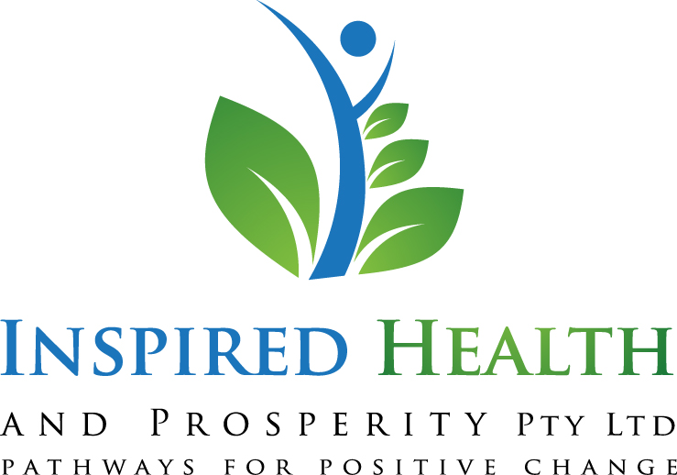
Holistic Health Workshop
STRESS

The physiological and psychological impact of stress and natural ways to overcome it!



www.inspiredhealthandprosperity.com.au
PRESENTED BY KIM SANDGREN
HOLISTIC KINESIOLOGIST, INSPIRATIONAL SPEAKER, LECTURER, SECONDARY EDUCATION TEACHER.
B.Ed. Dip Hlth Sci. ATMS. AKA
Appointments: 0439901125
Office 5, BREED Business Centre, Hoskins St, Temora.

Much of the information provided in this training has come from touch for health, kinesiology, traditional Chinese medicine, and meditation. All of the theories and techniques taught are of sound philosophy and scientific research and are simple and safe to utilise with a variety of people. Although each persons experience with stress is as unique as their recovery process, simple and effective techniques can significantly aid in their recovery.
Listen to your body… It is trying to tell you something!
 | Never | Sometimes | Often
Tired, yet unable to sleep
Thin limbs but with wobbly water bottle weight around middle
Gain weight but unable to lose it
Tremble under pressure
Feel better suddenly for a brief period after a meal
Crave stimulants including sugar, coffee, cola, carbs
Need an alcoholic beverage to be able to relax
Crave salty, fatty, high protein food like meat and cheese
Bad PMS
Pain in back and neck, with no apparent reason
Difficulties getting up in the morning
Light headed
Poor memory – retell a story, forget names
Start another task before the first is finished
Bump into things, kick toes
Early greying of hair
Unexplained hair loss
IBS – changeable bowels
Gastric Reflux
Dry and thin skin
Lethargy and Lack of energy
Increased ability to perform daily tasks
Chronic Fatigue Syndrome
Get sick as soon as you “stop”
Anxiety, palpitations
Food and inhalant allergies
Stress Incontinence – sneezing, coughing, laughing
Low sex drive
Bruise easily
Acne
Calf cramping at night
Cramping under foot
Muscle aches and pains - toxicity
Get up numerous times to go to toilet at night
Light sensitive – squint, need sunglasses
Night sweating
Masculising effects
Headaches and Migraines
Jaw stiff and tight, grinding teeth
Depression

What is your body trying to tell you?

Signs of long term trauma on the body The evidence is overwhelming that a buildup of stress hormones long term, causes long term health issues. From disorders of the nervous system, migraines, IBS, chronic fatigue, HBP, infertility, lupus, allergies, arthritis, depression, anxiety, incontinence, and other more sinister autoimmune diseases including cancer.
Start listening now!!!

What triggers your stress response???

Your perception = your reality
Healing comes from a shift in consciousness
Once I am listening, what can I do to balance my body???

Balance Idea # 1: Nutrition – we are what we eat

- Increase good quality, easily absorbed water
- Increase Protein and good quality vegetables
- Avoid cereals in the morning
- Chocolate cravings = low magnesium levels. Foods high in magnesium such as kelp, almonds, cashews, beans, peas.
- Slowly reduce stimulants including sugar and sugar containing products, caffeine products, white products

http://www.watercure.com/wondersofwater.html
http://www.vaughns-1-pagers.com/food/magnesium-foods.htm
http://www.compassionateacupuncture.com/decreased_adrenal_function.htm

Balance Idea # 2: Inhale air, not your food

- Always sit down to eat
- Eat with the intention to nourish yourself
- Distribute your weight evenly
- Don’t flex your calf muscles

Balance Idea # 3: Recognise when your body needs extra support

- Vitamin B
- Vitamin C
- Herbal Tea – Licorice, chamomile, passionflower, valerian
- Tissue Salt Combination 12 – Fatigue and Exhaustion
- Rescue Remedy

Balance Idea # 4: Nurture your body and mind with relaxation

- Aromatherapy – lavender, vetiver
- Candles
- Bath
- Spa and sauna treatments
- Music
- Exercise – walking and resistance training

http://www.holistic-online.com/Stress/stress_aromatherapy.htm

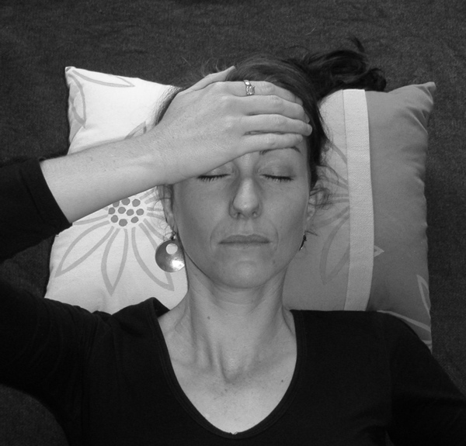
Balance Idea # 5: Emotion Stress Release Technique

Light pressure, focus on breathing deep into the abdomen

- Emotional overwhelm
- Fear
- Shock
- Panic
- Anxiety
- Tension
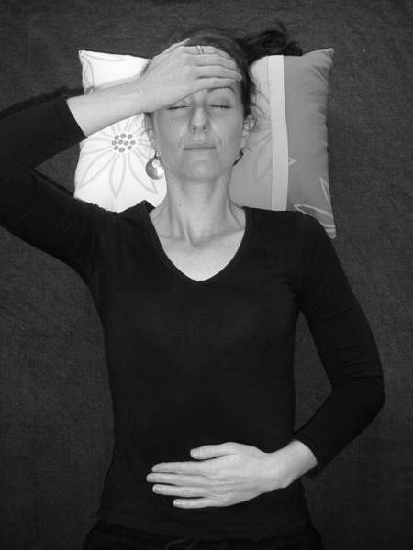
Balance Idea # 6: Advanced Emotion Stress Release Technique

Light pressure, focus on breathing deep into the abdomen

- When stress is high and digestion is affected
- Shallow breathing
- Feeling out of control/spread too thin
- Needing balance and relaxation

Balance Idea # 7: Brain Calming and Clarity Technique
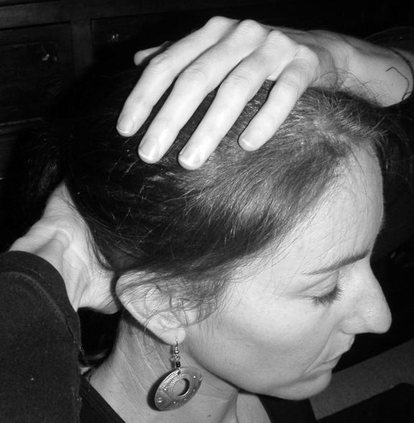
Light pressure, focus on breathing deep into the abdomen

- Confused
- Mental overwhelm
- Over-thinking
- Forgetful

Balance Idea # 8: Grounding Techniques
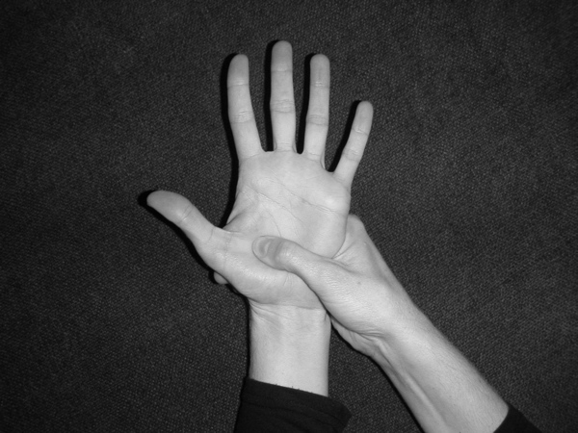
- Calf muscles are sore
- Your tendons on your feet hurt
- Digestion problems
- Night sweating
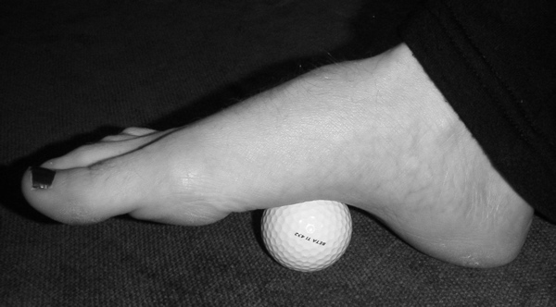
- Maintenance

Balance Idea # 9: Fight/Flight Point
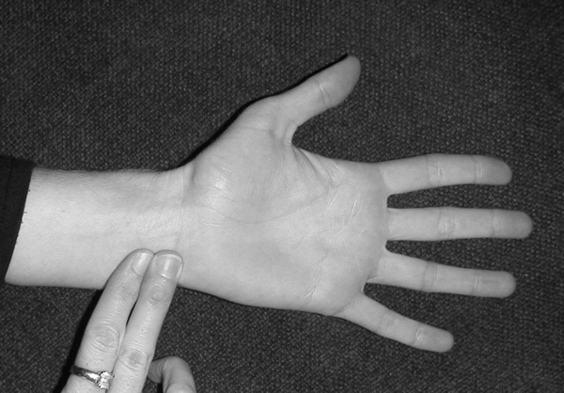
- Anxiety, heart palpitations
- Trembling
- Fear
- Stress with physical response
- Night sweating

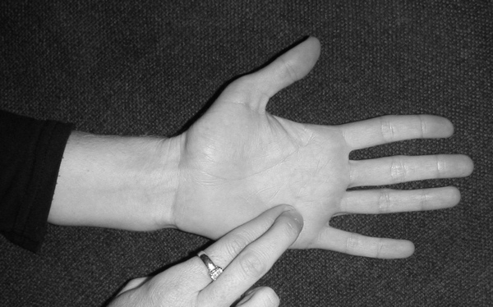
Balance Idea # 10: Fear Point

- Palpitations
- Incontinence
- Scared about what might happen
- Can’t sleep
- Worry, vigilance, sadness
- Feel like I am being controlled by others

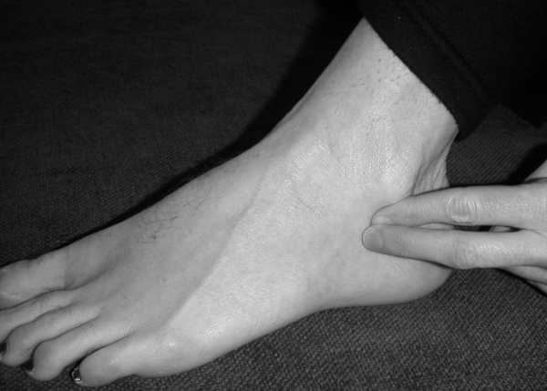
Balance Idea #11: Resilience Point

- Sad and given up
- Depression
- Taking charge of your life

